RFC

RFC: Log Ingestion

Driver
Jeff Nadler

Working Group
Name
Antonio Lorenzo Michael Fuller Ben Kulp Atsuhiro Ishikawa Jeff Nadler

Stakeholders
Name | Status | Opinion / Alignment | Date
Scott Algatt | Complete | Aligned | Mar 11, 2025 12:00 AM
Billie Cleek | Complete | Aligned | Feb 18, 2025
Nick Saika | Complete | Aligned | Mar 10, 2025
Brian Kopp | Complete | Aligned | Mar 4, 2025
Zeb Sampedro | Complete | Aligned | Mar 10, 2025
Ben Howard | Complete | Aligned | Mar 10, 2025
Max Fedotov | Complete | Aligned | Mar 4, 2025
Andrew Melton | Not started | Undecided | Date

Problem Statement
Today we ship logs only to SaaS services like Sumo Logic and Datadog. Logs are picked up by an OpenTelemetry collector, and shipped directly to the SaaS API endpoint.
Observability will be deploying an on-premises log datastore soon, and this existing “direct to destination” model of delivering logs from edge collectors will then be a significant obstacle:
- The log datastore won’t be network-reachable from everywhere we generate logs
- No “choke points” exist in the current architecture where we can bulk process logs for purposes like rate limiting and data enrichment
- Not possible to permit other Lambda teams to consume logs in a loosely-coupled way
- Limited ability to store and forward logs during a WAN outage at one of our sites results in data loss

Requirements
We will provide a log ingestion pipeline that offers:
- Ingestion: Logs are written to the new log datastore. Gradual migration from Sumo Logic to the new logs datastore must be supported, including shipping logs to both Sumo and the new datastore simultaneously.
- Store and forward: The DIA links to DCs are notoriously vulnerable to backhoe-related outages, and we drop logs today when this happens. Logs should be stored for a configurable period in the DC for forwarding when the outage is resolved.
- At Least Once Delivery: Logs should be replicated and must not be lost unexpectedly in transit, but the complexity of preventing duplicate delivery (“exactly once” semantics) is not justified for this data stream.
- Security: Authentication must be required to access log data in the pipeline. Data should be TLS encrypted in flight.
- OTEL Support: Any logs that can be picked up by an OpenTelemetry collector must be able to be forwarded to the log ingestion pipeline. This implies Syslog support, since Observability already offers syslog to OpenTelemetry bridges.
- Subscribers: We should support external (from the Obs team) subscribers who can consume log data in a loosely-coupled manner. The Security team already has requirements in this area, and others will follow.
- Rate Limiting: Today we do not have a log rate limiting solution, so cost control is a source of toil for the Obs team. Log floods are a fact of life, so we want an automated solution for detecting and suppressing them. In a future where we have a service catalog, we’ll be able to automatically notify the owner team.
- Public Net Ingest: Provides a secure ingestion endpoint on the public internet for use cases like private cloud and inference that are not on the Lambda internal network.
- Enrichment / Transformation: The pipeline design can support arbitrary future data enrichment or transformation of logs, for example deriving metrics from log data.
- Low Latency: Logs should be submitted to the log datastore within 60 seconds from generation.
- Operable: The pipeline itself is scalable to hundreds of thousands of messages per second (we see peaks at about 9k logs/s today), low maintenance, observable, can be run on Lambda k8s, and has a configuration solution for behaviors like rate limiting and enrichment. When complete this is expected to reduce toil for the Obs team.

Solution Description
We propose to build a new log ingestion pipeline based in part on NATS messaging. This will require the development and deployment of the following components:
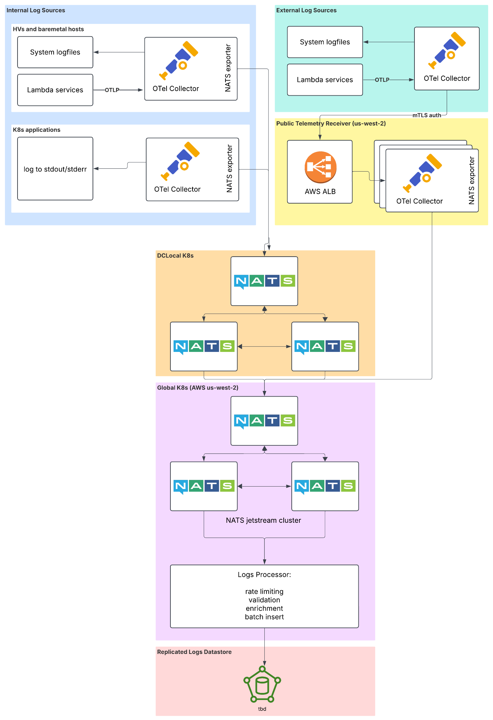

Edge OpenTelemetry Collectors (Lambda Internal)
We maintain collectors on every GPU HV, CPU HV, and other hosts in our datacenters. Core Infra runs log collectors in each k8s cluster on every node. Most of these collectors are based on the opentelemetry collector distro that Lambda maintains.
We do not anticipate the need to deploy new collectors to implement this pipeline, but we will need to upgrade both the code and configuration of those collectors to ship logs to the NATS leaf nodes in each datacenter instead of directly to a provider like Sumo Logic.

External Log Sources

Some environments, like Private Cloud clusters and our Inference product, run outside the Lambda internal network.

To provide logging solutions for these use cases we will build and operate a Public Telemetry Receiver capable of receiving logs using the OpenTelemetry protocol (OTLP).

This data stream will be secured with mTLS authentication. For each external system, we will issue a client certificate that will be presented with the connection. An AWS Application Load Balancer will validate the certificate, terminate the encryption, and pass the OTLP stream on to an OTEL collector.
The collector will export the data stream to the global NATS cluster, running in the same k8s cluster.

OpenTelemetry and NATS
An OTel collector uses a component called an ‘exporter’ to ship telemetry data outbound towards a destination. Exporters exist today for some messaging systems like Kafka, but despite the growing popularity of NATS there is no NATS exporter available today.
We will build a new nats exporter for opentelemetry. We plan to only implement logs data shipping to NATS at this time; we may also implement metrics and traces in the future but they are not required at this time.
This exporter will have a new github repo, and we will include this exporter in the opentelemetry collector distro that we already maintain.

NATS LeafNodes
In each Lambda datacenter and in the OCI Phoenix region, we will deploy a NATS jetstream leaf node cluster - at least 3 pods for availability. These will run in Core Infra’s local Kubernetes cluster in that DC. We propose to use Local Persistent Volumes to provide storage to the NATS pods.

Local volumes are chosen because the data is all transient, stored for hours at most, and the alternative is VAST persistent volumes which are back by NFS. NFS isn’t ideal for what is effectively a write-heavy database file due to the possible introduction of latency and concerns around consistency and file locking.

The streams on these leaves will be configured with MaxMsgs set to an estimate of 12h normal log volume for the DC. Observability will review these limits periodically to maintain a reasonable buffer. The DiscardPolicy will be set to DiscardOld, so that the newest logs are available to “catch up” after an outage longer than MaxMsgs can support.
The edge OTel collectors in a DC will write logs to these NATS leaf nodes in the same DC. As long as the local network is up, logs can be delivered to an aggregator where they are persisted via jetstream.
The leaf nodes will stream logs to the global NATS cluster.

DC WAN Outages

During a WAN outage, logs will accrue on the leafnodes’ volumes. The NATS jetstream storage limit will be set to 90% of the size of this volume. When the storage limit is reached, the oldest messages will be discarded.

We will set the volume size through experimentation with the goal that at least 12 hours of logs are retained during loss of WAN links. As log volumes increase and we deploy larger DCs, it may not always be possible to retain 12 hours of logs - we will adjust based on the available disk space and to ensure that the time-to-recovery is not excessive. During the catch up period after an outage, realtime logs from the DC are not available, so it is important to choose a retention period as a compromise between filling the entire “gap” from the outage and getting caught up to enable triage as quickly as possible.

When the outage is resolved, the leaf nodes will automatically deliver the stored logs to the global NATS cluster.

Global NATS Cluster

We will deploy a NATS cluster in the us-west-2 kubernetes cluster using the nats-operator. A minimum of 5x nodes spread across 3x availability zones will be used so that the cluster is resilient to loss of a single AWS AZ. All logs will be delivered to this cluster.

The cluster will be configured with TLS certificates and will encrypt traffic in-flight to/from the cluster and between the cluster nodes. Authentication will be required to connect to this cluster.

Log Consumers for Other Lambda Teams
This cluster can be used to provide log access to other teams outside of Observability, without tight coupling between our systems. The security team will be our first external customer for access to the log stream.

We plan to distribute logs using Subjects for each datacenter, so it will be possible to consume at the DC level or all logs globally.

We will provision unique user accounts for each team that requests a log stream consumer.

Log Processor

We will build a new application using Go to process the log stream and write logs to our new (not yet selected, that’s the next RFC) datastore.

We will perform a number of operations in this application:
- Rate Limiting: We will establish a default rate limit per-service and a facility for configuring overrides for services that need a higher quota. The rate limiter will use the token bucket algorithm. When a rate limit is exceeded, logs from the service will be sampled at a rate of 1:100 until the token bucket has refilled. We will emit metrics on rate limiting, and create a dashboard that makes it easy to see if services are currently hitting rate limits.
- Validation: Logs are required to provide a minimum set of fields to identify their source. Logs that fail validation will not be discarded, at least initially, but we will enrich those logs with a field that makes it easy to search them. This will help the Observability team to work with other teams to improve log quality over time.
- Enrichment: No enrichment is planned in the initial release, beyond that described in ‘Validation’ above. Lambda will in the future develop a service catalog with a variety of metadata about our services; at that time it will likely be useful to enrich logs with metadata such as the team that owns the service.
- Insert: The log processor will batch insert log messages into the new us-west-2 log datastore. During the transition period, it will also ship logs to Sumo Logic.

Assumptions (Optional)
A variety of options exist for collecting log data. Log-centric or observability-centric solutions like fluentd, vector, rsyslog, promtail and filebeat are widely used. The broader observability community, particularly within tech, has been increasingly adopting message brokers like Kafka and NATS. We already have one team outside observability wishing to “subscribe” to the log stream, and we anticipate more in the future. This isn’t supported well by the observability-centric platforms, leading us to prefer a solution based on a scalable messaging platform.

NATS is emerging as the de-facto messaging platform used at Lambda. We believe it is an excellent choice for the logs pipeline. Because it appears to be on the cusp of broad adoption here, we only briefly considered other messaging infrastructure.

Risks (Optional)
We do not yet have an OCI k8s cluster, but the Core Infrastructure team has one in the planning phase. It is expected by the end of Q2.

Both the global NATS cluster and the log datastore are planned for deployment to us-west-2. We will deploy across 3x AZs to get resilience against the loss of a single AWS datacenter. Lambda does not yet have a DR strategy to address the possible loss of the entire AWS region. Without a hot secondary of the AWS portion of the log pipeline, logs will be completely unavailable in the event that this AWS region goes down.

Observability will be building and operating the NATS infrastructure initially. Platform (Core Infra) plan to offer NATS as a solution in the future and we expect to incorporate that shared platform with our log ingestion pipeline when it becomes available, but until then we will be responsible for upkeep of 100% of the NATS infrastructure we use, which carries risks relating to lack of experience. We plan to mitigate those risks as much as possible through pre-launch testing and consulting with more-experienced ICs within Platform as we build.

Alternatives (Optional)

What alternatives were under consideration and what tradeoffs did they have? Consider both advantages and disadvantages of each option and a short summary of any aspects that make them unsuitable.

Kafka was considered briefly as an alternative to NATS, but was ultimately not selected in order to align with Platform’s long-term goals. We believe that both systems would meet our requirements, so ease of future migration and adoption became a key differentiator, with Kafka losing out.

